*High Level Design –* ***Aspire***

***Overflow***

**Document ID: Author(s):** Aurora

**Version:** 0.1

**Date:** April 18,2022

**Table of Contents**

Shape

1. Introduction
2. Non-Functional Requirements
3. System Architecture
4. Data Model
5. Database Diagram
6. Services

**Introduction**

This document provides a detailed design of the system. It starts with the design principle used, list the non-functional requirements and a detail description about the subsystem or components which comprise the system and their interactions.

**Non-Functional Requirements**

### **Maintainability:**

In Aspire overflow we will maintaindata’s (user specific data’s, articles

and etc.)

### **Performance:**

Our system designed and built with an acceptable standard of performance as a minimum. Taking into account areas such as load performance can be negatively affected by high numbers of API calls, poor caching procedures

### **Scalability:**

Aspire overflow system is able to accommodate larger volumes (whether of users, throughput, data) over time, and also includes NFRs such as elasticity, which is the ability to scale up and down quickly, as needed.

### **Usability:**

Aspire overflow is Usable systems are straightforward to use by as many people as possible, whether this is end-users of a website, or administrators and content editors working with a back-end system. Accessibility is another crucial element when considering the usability of the system, particularly if your target audience has specific needs or a low level of digital literacy.

**Capacity:**

As Aspire overflow is used within the organization

**Security:**

Only the users who are within the organization can view the website with verified employee details

**Usability:**

The website’s interface has to be user-friendly and easy to use.

**Serviceability:**

The applicants’ automated emails can be edited and replaced by uploading an XML file; there’s no need to recompile any code.

**Availability:**

Employers can publish articles and raise quires on the website throughout the week at any time. In the case of unplanned system downtime, all features will be available again after one working day.

**Reliability:**

Applicants can access the website at any time without failure.

**System Architecture**

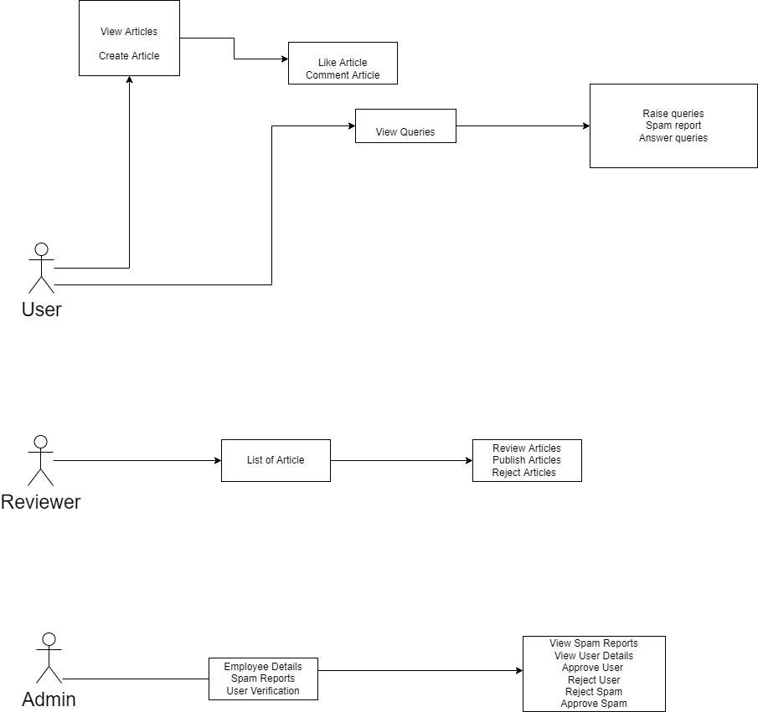

**Data Model**

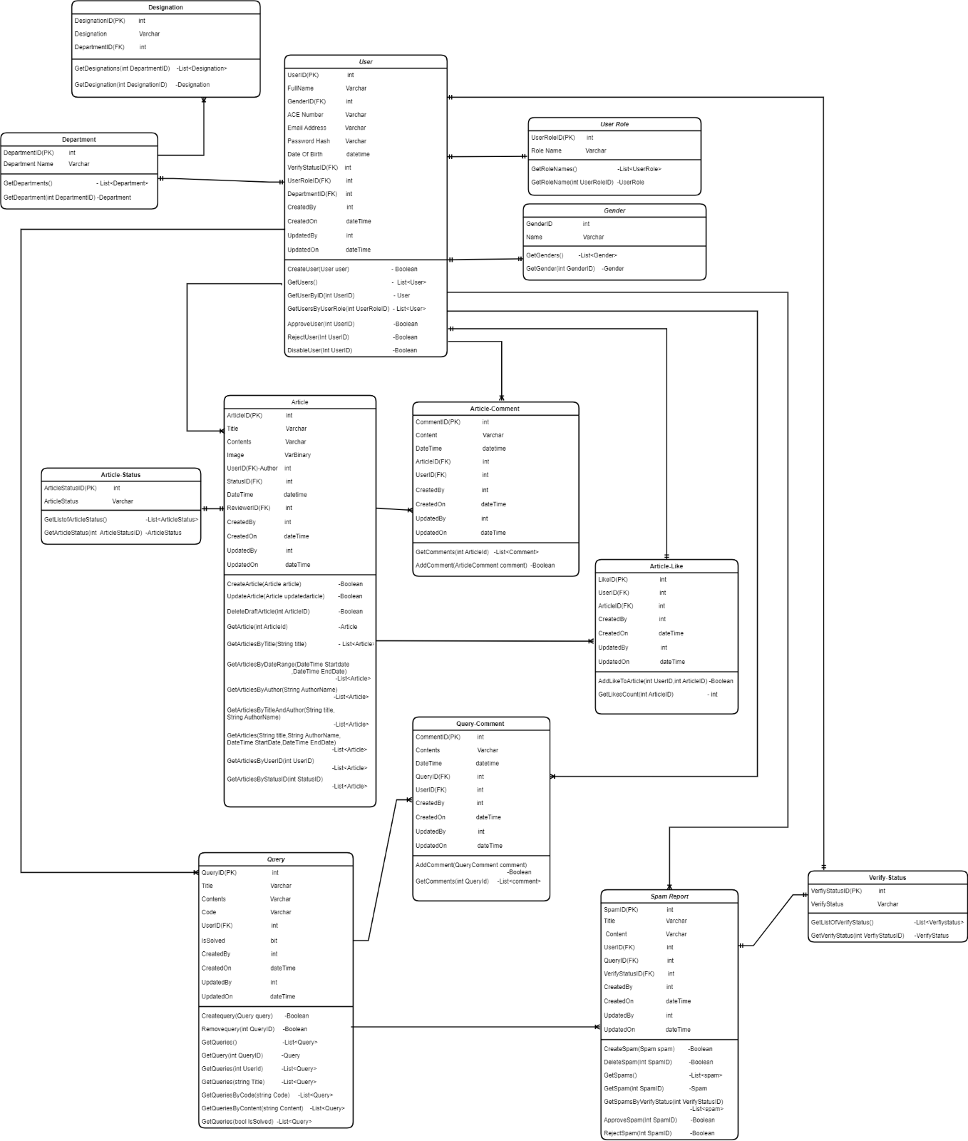

**Database Diagram**

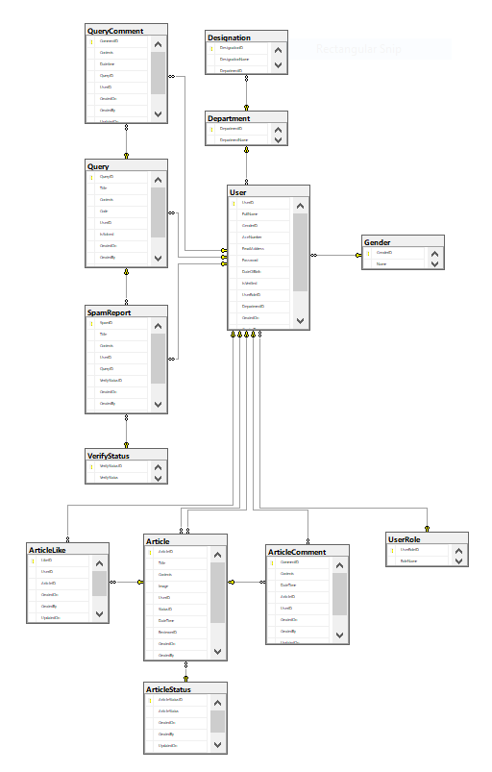

**Services**

